  A JSW ONE PRODUCT | STANDARD OPERATING PROCEDURE | Document ID:JODL/PB PT/010
 |  | Version: 1.0
 | Finishing Activities- Pipes & Tubes | Date: 7/02/2026

Purpose:

To establish a standardized process finishing, inspection, packing, storage, invoicing, and dispatch of pipes and tube

Scope:

Pipes & Tube Operation, Dispatch, Planning & Scheduling, Sales, Biz-ops teams, JOTS,

Teams and Responsibilities:

Sl No | Team | Responsibility
1 | Contract Manufacturer | Weighment, Loading, Tagging, Seller Invoice, Loading Advice, Vehicle release, Bundling
2 | JOTS | Vehicle arrangement, DO generation, Vehicle placement, Vehicle covering and sealing.
3 | Dispatch team | Loading check, Invoice, LR, E way bill
4 | Quality | TC, Material Quality check

Process:
A. Material Transfer from Production
- After production, Pipes/tubes transferred to finishing area
- Record production quantity.
B. Finishing Operations
The following operation needs to be done as per the requirement
- End facing(if required)
- Straightening (if required)
- Surface oiling (If online oiling not done)
C. After the finishing activities, Bundling & packaging needs to be done as mentioned below.
1. Bundle size as per standard weight mentioned in the annexure. Number of tubes may vary also based on customer requirement.
2. Use MS/steel straps (4 Nos)
3. Straps should be tightened by pneumatic machine
4. After Bundling & strapping, Tags to be placed in each bundle. Tag should contain the following information. Min 2 tags per bundle to be use.

- Size
- Grade
- Date
- Shift
- Batch ID
- Bundle ID
- Weight
- Number of tubes
- IS code
5. After Bundling, materials to be stored in FG storage yard
6. Records of the FG bundled materials to be entered in the register.

Annexures- A
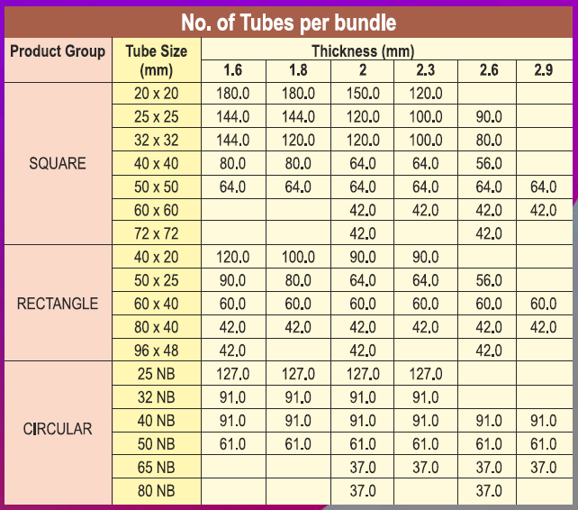
Annexures- B
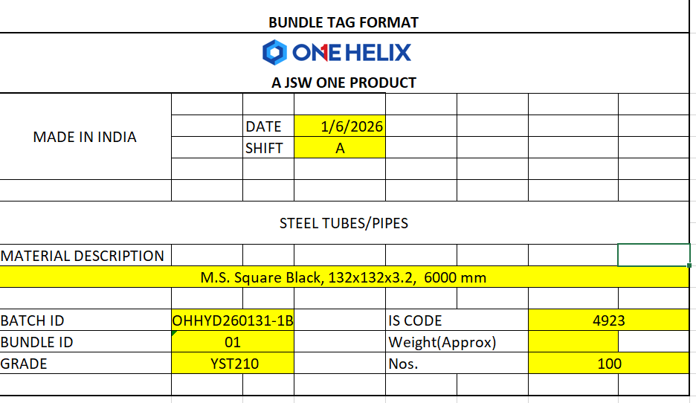

Annexure –C (Bundle Strapping)
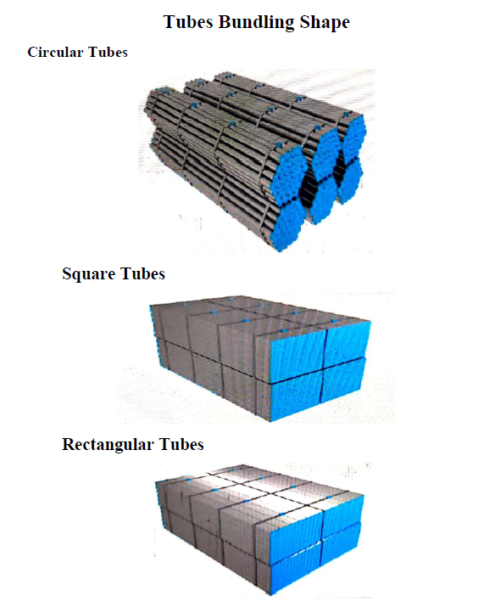
Created by: | Approved by:
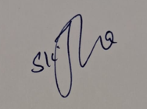  JSW One Operational Head | JSW One

